
GIC - IMAGE CAPTURE API INTEGRATION GUIDE



GIC - Image Capture API Integration Guide

Table of Contents
Table of Contents 2
- Revision History 3
- Preface 3
  - About Audatex and our solutions 3
  - About this Guide 3
- Getting Started 3
- Prerequisites 4
- Technical References 4
  - API Summary 4
  - Image Attachment Process Overview 5
  - API Specifications 7
    - Authenticate - Audatex / Audatarget 7
    - Get images, vin Mileage and User comments 9
    - Authenticate - Audatex / Eagle 10
    - Map images, vin Mileage and User comments 12
- Establishing a secured connection with Audatex EAPI 14
  - Securing Connection Options 14
    - Audatex to Client 14
    - Client to Audatex 14
- Test Connectivity and Data Flow 14
- User Acceptance Testing (UAT) 14
- Going Live 15
- Technical Support 15
- Contact US 16

Revision History

Version | Date | Author | Notes
1.0 | 06/29/2022 | A.S, Audatex | Version 1.0

Preface

About Audatex and our solutions
Audatex claims solutions will improve productivity and drive faster, more accurate estimating, valuations, and insight for your business. We bring together a unique blend of insurers, collision repair professionals, independent appraisers, and manufacturers to assist in your automotive claim. The result is improved cycle time, along with streamlined communication and accuracy that you can count on.

About this Guide
This guide provides the necessary information to describe the steps needed to follow to create an image attachment message. This guide describes what you need to know to do the following:
    - Get started with your GIC integration
    - Access the GIC Data Mapping
    - Contact Audatex Technical Support

Getting Started
Integration with Audatex EAPI services is fast and simple. Just follow these 7 steps:
- Meet pre-requisites
- Review technical specifications
- Develop integration services on your side
- Establish a secure connection with Audatex EAPI
- Test connectivity and data flow
- Complete User Acceptance Testing (UAT)
- Go Live

Prerequisites
Clients must work with Audatex to review the scope and requirements of the integration. This phase will ensure all prerequisites are met to ensure a successful integration.
- The Client must be able to consume and expose RESTful APIs
- The Client must have a segregated development and test environment to complete Audatex EAPI testing and UAT. Audatex account representative will work with the Client to schedule and host a kickoff meeting. This meeting will be used to introduce critical technical resources, review the implementation timeline, and help answer any questions.

Technical References

API Summary
The following table contains a listing of the APIs included in this documentation:

Verb | Owner | Route | Description
POST | Audatex | https://<base-url>/connect/token  UAT base-url: “dispatch-login-demo.audatex.com”  Prod base-url:” dispatch-login.audatex.com” | Authenticat es client and provides access bearer token.
GET | Audatarget | https://us-services-demo.auda- target.com/Images/api/v1/ImageCollection/{CollectionID}/TenMP | HTTP Get  method for retrieving a list of images
GET | Audatarget | https://us-services-demo.auda- target.com/ImageRequests/api/v2/ImageRequest?imageRequestId={C ollectionID} | HTTP Get  method for retrieving Vin mileage and user comments

Image Attachment Process Overview
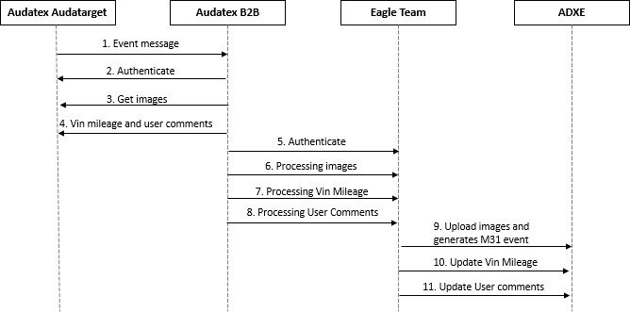

- Audatarget event message is completed.
- Audatex EAPI authenticates with Audatarget API
- Audatex EAPI retrieves (HTTP Get) images contained.
- Audatex EAPI retrieves (HTTP Get) Vin Mileage and user comments contained.
- Audatex EAPI authenticates with Eagle API
- Audatex EAPI process images to Eagle API
- Audatex EAPI process Vin Mileage to Eagle API
- Audatex EAPI processing user comments to Eagle API
- Audatex Estimate (ADXE) upload images and generates M31 event
- Audatex Estimate (ADXE) updates Vin Mileage
- Audatex Estimate (ADXE) updates user comments

Once the image request is completed, is when can create an image attachment, in order to send the message to the service bus. Use the POST-ImageAttachment request in postman with the correct credentials, and set the values needed in the JSON as follow:
{
"imageCaptureId": "A215EB8D-A9E7-4835-B68C-9F345DC687B0",
"estimaticImageAttachment": { "sourceSystemKey": "taskid", "sourceSystem": "ADXE", "country": "CA" }
}

Later than uploading the last images, Audatex will send the additional parameters for generating M31 event (Mobile event) and notify the client. Below is an example of the message generated.

Audatex will retry up to 3 times every 10 seconds when it doesn't get "success" from the customer service, after that it will go to the reject queue.

Sample message for M31 event:
{
"messageType": "adxe.estimate.image-upload-for-mobile-completed",
"routingKey": "adxe.estimate.image-upload-for-mobile-completed",
"id": "c3ccbaa3-4a87-4826-947a-395d4737686b",
"body": {
"workAssignmentId": "208092037",
"createdForProfileId": "196TEST0037",
"eventSource": "adxe.estimate",
"eventSourceDetails": "Falcon 8.1.325.4a PROD",
"eventCode": "M31",
"eventDescription": "Images gets uploaded from the Mobile Client",
"eventTime": "2021/11/19T15:54:38.483Z",
"roleCode": "196.TEST,Appraiser:196admin",
"roleDescription": "",
"estimateStatus": "0",
"claimGuid": "",
"claimNo": "DEVT1_25112021",
"claimId": "115259627"
}
}

M31 Event process workflow:
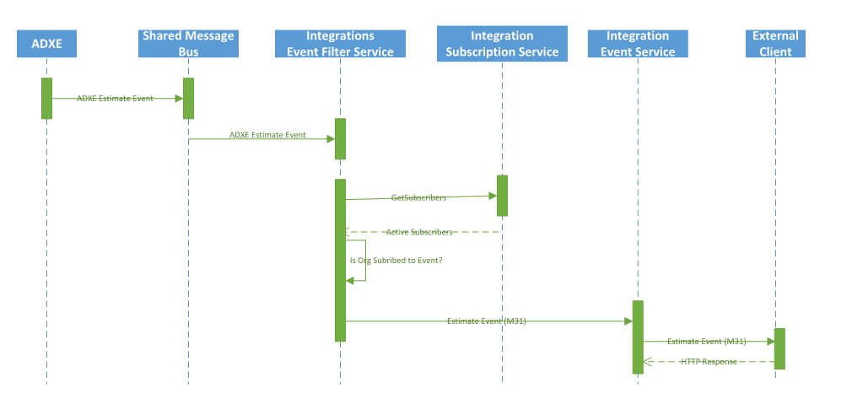

API Specifications

Authenticate - Audatex / Audatarget
Audatex EAPI will need to authenticate with Audatarget API when retrieving images, vin mileage and user comments

The following are the supported authentication methods from which one of them can be selected:
      - Basic Authorization
      - Bearer token

Method: POST
URL: https://<base-url>/connect/token Owner: Audatarget

This API authenticates the user based on the provided user id and password. A successful request returns the HTTP status code: 201 CREATED

Verb | Route | Description
POST | /api/authorize | Authenticates the user and provides access token.

URLs:
- TEST URL: https://auth-pat.auda-target.com/connect/token
- PROD URL: https://auth.auda-target.com/connect/token

Note. If the client needs the IP ranges for the configuration, the following IP addresses should be considered:

- Tanzu Test: 170.76.172.18
- Tanzu Prod: 170.76.172.20

Token Request

x-www-form-urlencoded
{
"Clientid”: " {client-id}",
"Secret”: " {client-secret}",
"Scope": “images.admin apigateway.imageattachment",
"grant_type": "client_credentials",
}

Token Request

x-www-form-urlencoded
{
"Clientid”: " {client-id}",
"Secret”: " {client-secret}",
"Scope": “imagerequests.admin ",
"grant_type": "client_credentials",
}

Data Dictionary

Key | Description
client_id | {client-id}
client_secret | {client-secret}
grant_type | client_credentials
scope | images.admin apigateway.imageattachment,  imagerequests.admin

Sample Auth Response
{
"access_token":
"eyJhbGciOiJSUzI1NiIsImtpZCI6IjZBMDk2MkY5MDg4MERBOTQzMzhBODgzRkVDQkNGMzZEN DkwQzY5RkIiLCJ0eXAiOiJKV1QiLCJ4NXQiOiJhZ2xpLVFpQTJwUXppb2dfN0x6emJVa01hZnMifQ. eyJuYmYiOjE1NTM1NTAwNTEsImV4cCI6MTU1MzU5MzI1MSwiaXNzIjoiaHR0cHM6Ly9kaXNw YXRjaC1sb2dpbi1kZXYuYXBwcy5wcmVwcmRwY2YwMS5hdWRhZXhwbG9yZS5jb20iLCJhdWQi OlsiaHR0cHM6Ly9kaXNwYXRjaC1sb2dpbi1kZXYuYXBwcy5wcmVwcmRwY2YwMS5hdWRhZXh wbG9yZS5jb20vcmVzb3VyY2VzIiwiYjJiLmZub2wuYXBpIl0sImNsaWVudF9pZCI6ImIyYi5mbm9sI iwic2NvcGUiOlsiYjJiLmZub2wuYXBpIl19.PJHkblYSg1ABUMMNoLt_uf8jUU682WMGbA0X04to0 L_CgylxMD8bVlCZYXBD9AhF09xCOShiONkTWqOLkAmEY9V7Q4Y1Kj7wwaBQmhzjeyGn5XRrXVhHhu1W mjSLIYKYNeKYqbnvBLkN6Jt dPhxTchYzdt2C6Wzo2_jnXBN9LcCj18H9R3Q71RNwiZ0oWY3VFfl_x- Y33TDzKl69FrEwfCFLgiQpUqk9nvGx-86o18Denb0Id8vMwxjm05heRrL- uA3jaNMNp82opmUhSw6Jq_5MVEPD7gXQ99I8ofTAqOXkwwavJOL9QM0R- uy837rawy_WW4fPvN0291xYZZJ5zurHPiZCqAduHx9okk7aIFtj1pyXlmwlF3XISF2EonK_cWWpI 4t3kHAHQbYkmafqQkWSmXtY85nOlSb7oV72qqtxUFaMbkA- kQnoj6TtEuYuA92dJrlKGM2EvKBeV6vu2J2wqErFzUoyZMVzAtj7RV0hYl7maY1mbCBR7c9Sfgcg 3wO972d7AeFwaAs-
CX1QN0H20Pfq5TefBMulerI75nGjPo2WptAQm2NGxar79VvQEwyyL9mEHTg- WXCU80aK5QBagwzfU6GkV6wPWqwW3m6GkeWheIS2Gj8X6VwBoJDpOYyDk2_4XSIbVAQKz V9P3TtR0a0FEsBK9pjl2KVKc",
"expires_in": 43200, "token_type": "Bearer"
}

Data Dictionary

Key | Description
access_token | authentication token
expires_in | token TTL in seconds
token_type | Type of authentication

Get images, vin Mileage and User comments

Verb | Owner | Route | Description
GET | Audatarget | https://us-services-demo.auda- target.com/Images/api/v1/ImageCollection/{CollectionID}/TenMP | HTTP Get  method for retrieving a list of images
GET | Audatarget | https://us-services-demo.auda- target.com/ImageRequests/api/v2/ImageRequest?imageRequestId={C ollectionID} | HTTP Get  method for retrieving Vin mileage and user comments

Method: GET
URL: To be defined by client Owner: Audatarget

Attached below is an example response to get images, vin mileage and user comments.

Request Sample JSON to get images


Request Sample JSON to get vin mileage and user comments


Authenticate - Audatex / Eagle
Audatex EAPI will need to authenticate with Eagle API when processing images, vin mileage and user comments.
The following are the supported authentication methods from which one of them can be selected:
      - Basic Authorization
      - Bearer token

Method: POST
URL: https://<base-url>/connect/token Owner: Audatex

This API authenticates the user based on the provided user id and password. A successful request returns the HTTP status code: 201 CREATED

Verb | Route | Description
POST | /api/authorize | Authenticates the user and provides access token.

URLs:
- TEST URL: https://dispatch-login-demo.audatex.com/connect/token
- PROD URL: https://dispatch-login.audatex.com/connect/token

Note. If the client needs the IP ranges for the configuration, the following IP addresses should be considered:
- Tanzu Test: 170.76.172.18
- Tanzu Prod: 170.76.172.20

Token Request

x-www-form-urlencoded
{
"Clientid”: " {client-id}",
"Secret”: "{client-secret}",
"Scope": “eagle.api", "grant_type": "client_credentials",
}

Data Dictionary

Key | Description
client_id | {client-id}
client_secret | {client-secret}
grant_type | client_credentials
scope | eagle.api

Sample Auth Response
{
"access_token":
"eyJhbGciOiJSUzI1NiIsImtpZCI6IjZBMDk2MkY5MDg4MERBOTQzMzhBODgzRkVDQkNGMzZEN DkwQzY5RkIiLCJ0eXAiOiJKV1QiLCJ4NXQiOiJhZ2xpLVFpQTJwUXppb2dfN0x6emJVa01hZnMifQ. eyJuYmYiOjE1NTM1NTAwNTEsImV4cCI6MTU1MzU5MzI1MSwiaXNzIjoiaHR0cHM6Ly9kaXNw YXRjaC1sb2dpbi1kZXYuYXBwcy5wcmVwcmRwY2YwMS5hdWRhZXhwbG9yZS5jb20iLCJhdWQi OlsiaHR0cHM6Ly9kaXNwYXRjaC1sb2dpbi1kZXYuYXBwcy5wcmVwcmRwY2YwMS5hdWRhZXh wbG9yZS5jb20vcmVzb3VyY2VzIiwiYjJiLmZub2wuYXBpIl0sImNsaWVudF9pZCI6ImIyYi5mbm9sI iwic2NvcGUiOlsiYjJiLmZub2wuYXBpIl19.PJHkblYSg1ABUMMNoLt_uf8jUU682WMGbA0X04to0 L_CgylxMD8bVlCZYXBD9AhF09xCOShiONkTWqOLkAmEY9V7Q4Y1Kj7wwaBQmhzjeyGn5XRrXVhHhu1W mjSLIYKYNeKYqbnvBLkN6Jt dPhxTchYzdt2C6Wzo2_jnXBN9LcCj18H9R3Q71RNwiZ0oWY3VFfl_x- Y33TDzKl69FrEwfCFLgiQpUqk9nvGx-86o18Denb0Id8vMwxjm05heRrL- uA3jaNMNp82opmUhSw6Jq_5MVEPD7gXQ99I8ofTAqOXkwwavJOL9QM0R- uy837rawy_WW4fPvN0291xYZZJ5zurHPiZCqAduHx9okk7aIFtj1pyXlmwlF3XISF2EonK_cWWpI 4t3kHAHQbYkmafqQkWSmXtY85nOlSb7oV72qqtxUFaMbkA- kQnoj6TtEuYuA92dJrlKGM2EvKBeV6vu2J2wqErFzUoyZMVzAtj7RV0hYl7maY1mbCBR7c9Sfgcg 3wO972d7AeFwaAs-
CX1QN0H20Pfq5TefBMulerI75nGjPo2WptAQm2NGxar79VvQEwyyL9mEHTg- WXCU80aK5QBagwzfU6GkV6wPWqwW3m6GkeWheIS2Gj8X6VwBoJDpOYyDk2_4XSIbVAQKz V9P3TtR0a0FEsBK9pjl2KVKc",
"expires_in": 43200, "token_type": "Bearer"
}

Data Dictionary

Key | Description
access_token | authentication token
expires_in | token TTL in seconds
token_type | Type of authentication

Map images, vin Mileage and User comments

Verb | Owner | Route | Description
POST | Audatex | https://{base-url}/attforeai?isLast={Y/N} | HTTP POST  method for uploading a list of images
PUT | Audatex | https://{base- url}/claims/{eagleData.workAssignmentId}/update?vin={vin}&mileage=  {mileage} | HTTP PUT  method for update Vin mileage
POST | Audatex | https://{base-url}/comments | HTTP POST  method for update user comments

Audatex EAPI will process the images to pass through to Eagle service

Method: POST
URL: https://{base-url}/attforeai?isLast={Y/N}
Owner: Audatex

Attached below is an example request parameter to upload images.

Sample JSON to upload images
{
"workAssignmentID": "{workAssignmentID}", "attachments": {
"attachment": [

{
"extension": ".PDF/.JPG",
"notation": "PDR Report",
"imageData": "JVBERi0xLjYKJeTw7fgKNCAwIG9iago8PC", "fileSizeInBytes": "101328"
}

]

}
}

Data Dictionary

Key | Description
workAssignmentID | {workAssignmentPK}
extension | .PDF/.JPG
notation | Notation for attachments
imageData | Encoded attachments
fileSizeInBytes | Size of encoded attachments

Audatex EAPI will process the user comments to pass through to Eagle service

Method: POST
URL: https://{base-url}/attforeai?isLast={Y/N}
Owner: Audatex

Attached below is an example request parameter to add user comments.

Sample JSON add user comments
{ "workAssignmentId": "{WorkAssignmentID}", "commentSubject": "Test subject", "commentText": "Test comment text", "author": "Test Author Name", "destinationEmails": "first.last@company.com"}

Data Dictionary

Key | Description
workAssignmentID | {workAssignmentPK}
commentSubject | Subject of comment
commentText | Comment
author | Name of author
destinationEmails | Author email

Establishing a secured connection with Audatex EAPI

Securing Connection Options

Audatex to Client
      - Whitelisting IP’s: Audatex will provide IP range so the client can whitelist to allow traffic to necessary resources.
      - VPN Connection – A VPN can be set up between the two parties to facilitate secure communication.
      - SSL over Internet
      - Supported authentications: Basic Auth and OAuth2 (See appendix for samples)

Client to Audatex
      - Endpoints are exposed using SSL protocol over the internet.

Test Connectivity and Data Flow
System Integration Testing will be performed in order to cover the below areas:
- Detect Defect early
- Get earlier feedback on the acceptability of the individual module
- Have flexibility on scheduling of Defect fixes, which can be overlapped with development
- To ensure data flow, control flow, timing, memory usage, and software requirements is correct

User Acceptance Testing (UAT)
Based on client requirements in the Project Charter Audatex will put forth a set of best practice test cases and work with the client to have an approved list of test cases to execute.

After developers have completed System Integration Testing (SIT) in the test environment, the insurance carrier or integration partner will work with Audatex integration teams to complete UAT in Audatex testing environments. UAT must be scheduled with Audatex to ensure resource availability for both parties.

Going Live
A production implementation can be scheduled no earlier than 5 business days after the UAT signoff from the Audatex client.

Technical Support

 | United States | Canada
API Availability | Audatex maintains full services hosting from 6:30 am EST until 12:00 am EST Monday through Saturday (Standard or Daylight Savings Time as applicable) and 10:00 am EST until 2:00 pm EST on Sunday. Services may be available outside of these time frames, but availability is subject to maintenance. | Audatex maintains full services hosting from 6:30 am EST until 12:00 am EST Monday through Saturday (Standard or Daylight Savings Time as applicable) and 10:00 am EST until 2:00 pm EST on Sunday. Services may be available outside of these time frames, but availability is subject to maintenance.
Scheduled Maintenance | Audatex reserves the right to do maintenance whenever necessary. Audatex will strive to limit downtime during normal business hours as outlined in Hours of Operation. Maintenance will normally be scheduled throughout the week. | Audatex reserves the right to do maintenance whenever necessary. Audatex will strive to limit downtime during normal business hours as outlined in Hours of Operation.  Maintenance will normally be scheduled throughout the week.
Emergency Maintenance | If emergency maintenance is required, Audatex reserves the right to provide the maintenance with minimal impact on the user community. | If emergency maintenance is required, Audatex reserves the right to provide the maintenance with minimal impact on the user community.

Support Center Hours | Technical assistance is available 8:00 am to 8:00 pm EST Monday through Friday and 9:00 am to 1:00 pm EST Saturday. | Technical assistance is available 8:00 am to 8:00 pm EST Monday through Friday and 9:00 am to 1:00 pm EST Saturday.
Support Center Contact Information | - Phone Number: 1-800-669- 4237  - For self-service support, please visit www.mysupportgarage.com  - To open a case for support, choose Contact Us.  - Emails will receive a response within 1-2 business days | - Phone Number: 1-866-420-2048  - For self-service support, please visit www.training.audatex.us  - Email canadatechsupport@audatex.com  - Emails will receive a response within 1-2 business days

Contact US

24/7 Training & Technical Support | MySupportGarage.com
Email Support | AXUS.AASupportContact@audatex.com
Contact Us | (855) 316-3205

